The most used platform in the world for now is Google (For now)

In google more that 100 billion search queries are put people are asking question to it

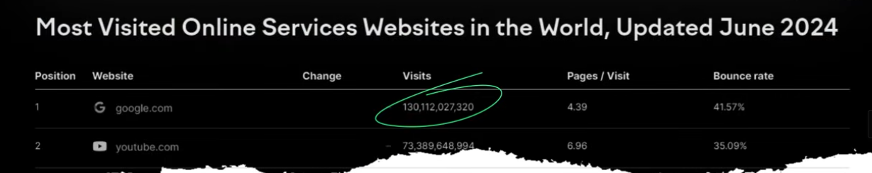

So in such cases if you have a website or business or Google or any other search engine any person searched anything related to your business or website related type it then you would not want that your website or your business should be on top by which you get more leads and visits so to do these things you need to bring your business or website on top we do an activity that we called SEO

So SEO is an organic marketing way inside which we optimize our website or bring some changes in it by which it will be ranked in top of google

The SEO is not that easy as you think because you need to make sure that your website should be best in terms of your competitor whether it is content

Whether we talk about off page or technical part

In everything your website should be best in comparison with your competitor then it will rank in first

If you want to learn about SEO and want to prepare for this demanding role

This course is perfect for you

Because in this full course you will learn about complete SEO in



On Page

OffPage

Technical SEO

How you use AI in SEO , Google analytics

Google Search console

And there are many things will make you an SEO expert

**Lesson 1**

In this lesson we will learn about **SEO introduction**

What is SEO?

It is a very basic concept but if you understand these things

Then you can do SEO whether we talk about practical or make people understand what is SEO why you need SEO

This think will be come easy for you

Because ,many times we need to make client understand that we are going to do SEO and what is this What are its importance So before that you need to know it your self

In this lesson we are going to understand it in simple language that what is SEO

Before we talk about SEO we talk about search engine that we are going to optimize

We go to Google

We are using google for years . Google is search engine we will talk about what is search engine

For now just thing google = search engine There are many but we will talk about google

Whenver we want to search something in google

Related to some bussiness like we search interior designing In Bengalore

We want services related to it inside bengalore

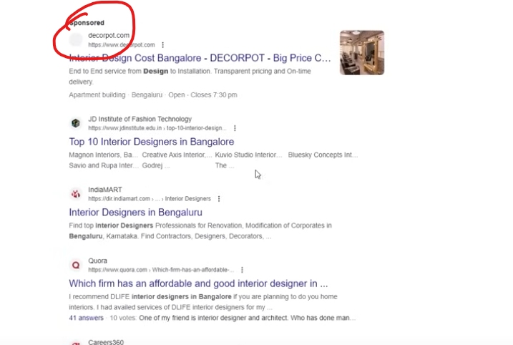

Then you can see above many search results

The marked one are the sponsored ads

Then the local business is shown in Google Map utility and here you can see many results

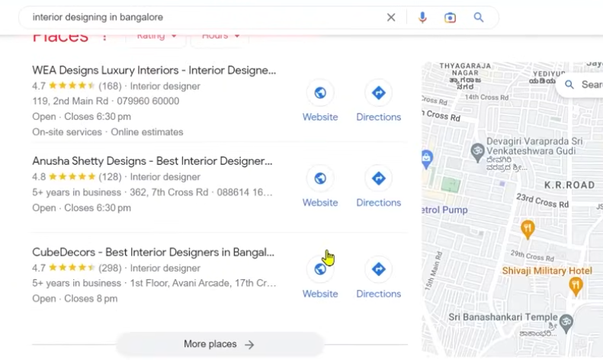

Approximately you can see 18 millions search result and in 0.58 seconds

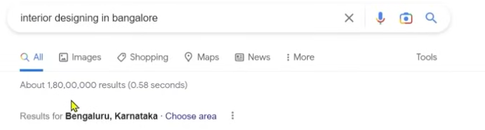

Now the point is raised that if we search aboutb some business thn we see million of results here

We will not talk about sponsored or paid results

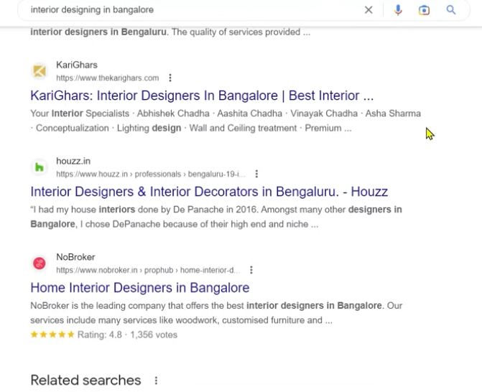

If we talk about above shown result

Then what special in them that they are shown in first, second and third and in reality we have million results

The point is that when we search anything in search engine then some result are shown in first . second and some in third position some in 100th or some in 1000th number . lakhs number

So the result come in first obviously we will click on it

Ask yourself does it happen that you search something and in the bottom of the page you click on the result there , going to 2nd page or 3rd page

If it has happened then it might have happened 2 or 3 percent times

SEO is that game

Our target will be that our business should come in top For that we use SEO

So we come again on SEO that what it is

The SEO is made with two word

First is search engine and another is optimization

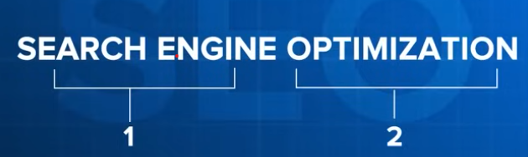

Here we are not optimizing our search engine then why I this named so

This name come because we are optimizing our website not search engine like you saw now that we did search something we enter a keyword

Let suppose you have website of interior designing and you serve in Bengalore

Would not you want that anybody search this query or enter this keyword in google then you website should be on top that’s why you need to optimize your website

By optimizing we mean managing your website or bring changes or correct things in it in such a way so that whenever someone search something related to our business then it should be on top this thing we call search optimization

We see its definition

It is important to understand it

**SEO is a process**

It is not a technique or on/off button that we on in our website and our website is in top or my website get off it come in bottom no

It is a process like if you have some small child how you make it learn .You first make it learn walking or sleeping you make it learn abcd, forming sentence So to make a child good human being or good citizen it takes a process. Similarly for normal website to become an optimized website that can rank in search engine it takes time, it takes a lot of steps It takes a process So it is a process and it is not one time process it is not like you do it one tiem and your website come in top your competitors are also working then these things keep changing and it is a process if you keep doing it then website will keep ranking top

**Of improving search engine ranking**

So what is this process what we do here is that our webpages ranking in our search engine is improved whenever someone type our business related keyword

Now here there is a word web pages

What is web pages and not website

Now what is website From childhood we have studied website is a combination of web pages Now our whole website is not ranked our web pages are ranked

Some times Home page is ranked sometime about us

Sometime contact us , sometimes internal pages get ranked

So SEO is a process where we improve ranking of our web pages when they need to be ranked when our bussiness related keyword is typed

Lets take old example

Your bussines is of interior designing

Some person is typing best salon in Bengalore

Then would you want that your website should be ranked obviously no that’s why when we will do SEO tehn our main goal will be that when someone type keyword related to your website or business then our website should be shown in top

**Web pages when people search for your business related keywords.**

Keyword is any words that we use to search something whether they are one word or 10 words nothing matters we call it keywords

So our web pages should be ranked when some one searches related to it

For that the process we are doing or optimization we are doing we call it SEO

Now why we do it

**It improves the quantity and quality of organic traffic to your website.**

Obviously by this our website quality or quantity of traffic is increased

We are talking about organic traffic

Paid traffic is when your are running ads and people are coming in your website but here we are talking about organic traffic for that we are not paying anything to google

We are making our website for google so good that people should come in our website so what happens by this is that when your website is ranked top then there will be while lot traffic there you think yourself when you search something in google tehn you go for 2nd ,3rd page No lets say you have a website and your business related keyword it ranked in 2nd page

Then do you think some audience will go there absolutely no but if it is ranking in 1st , 2nd or 3rd then off course you will get the traffic

11:10

So first target is that we should show our website in search engine

Now how we will show it we will talk about it in later videos that How a search engine work

How we put our website in it accordingly

Next our step will be to make the business website in top 10 in our business related keyword

By top 10 mean first page because According to teacher first page contains 10 website

So if we come in top 10 of first page lets say in 10th position

Then our target would be to come at top 5 and then Top 3 then in Top 1

Lets suppose we are ranking in number 1 in our business related keyword then you will leave as it is?

No because our competitor are also trying to come at first so that’s why it is a process you have to do it repeatedly

If you come at first then you need to try that to maintain that position we will also try to rank in other keywords This is SEO

So SEO is a process or activity which we do because , we optimize our website by which our web pages ranking will be improved when people type our bussiness related keyword

What happens by this is that our traffic quality or quantity is improved

Means more traffic will come and good quality will come which will be converted by convert we mean our customer will be made and lead will be generated

So that’s called SEO.

**Lesson 2:-**

In this lesson we will learn about **Why does SEO matter**

Why we do SEO why it is required

These things are important because eventually you have to make your client understand that’s why we want to do your SEO especially if we talk about India or Asia. Many people are not familiar about it. They are not familiar with its importance when these thins will be known by you then you will transfer this information with your client then only client will give you project because we have to tell about it by going to their places to tell them to do SEO they will gain benefit from it. So you should know these things

So why does it matter because these are the points as shown below

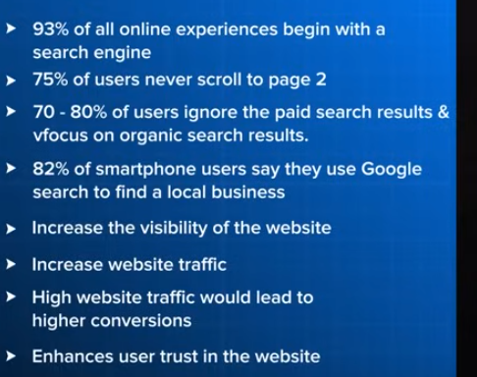

We will understand it one by one then it will be clear for you then you can convince others

So first all whoever the people are who want to engage in commerce or managing any business Their experience that they are searching something online Teacher ask us if we have used internet first time what did you use first what platform did you use

You used Whatsapp or Instagram , Facebook No we used Google Remember it

Usually people online experience start with search engine

You see any business lets say there is any business we don’t know that this business is popular or not It has good reviews or not So what we will do. We will go to Search Engine and see what people think about it how the website look

**Online experience of any business 93 percent times start with search engine** when we search something we usually go for Google. We use Google and see Google that what business it has

With this if we talk about as the Teacher told that there are many pages in Search engine

Whenever you type keyword you will see millions of result which are divide in different page

So **75 percent users never scroll to page 2**

So if there are your business related keyword and it is being ranked at 11th position or 12th position then it will not have benefit because 75 percent will not even go there

**70 to 80 percent of uses ignore the paid results focus on organic search result because they also know it is promoted ads**

Apart from it

**82 percent of SmartPhone users say they use Google search to find a local business**

If you have local business website then for you search engine is a very important thing

And **when our website will be ranked then visibility will be increased**

Which means you website reach will be increased and traffic will also increase

If there is traffic then we will get more convergence means we get more leads , get more customer, get more client. Lets suppose you get offline leads you business is offline you get offline leads so in that case that person will also check your presense online

Lets suppose today when someone search “digital marketing course in India” then WsCubeTech is shown in Top so in that case WsCube Tech name will be famous and theer will be branding that yes in digital marketing the couse is done by wscubetech and we have heard it anywhere because **it has enhanced user trust in the website** visibility has increased among them this is the biggest benefit of SEO whne you do SEO correctly your website is ranked then you get traffic , you get users, you get lead. So that’s why SEO is important

**Lesson 3**

In this lesson we will learn about **Job Opportunities in SEO**

If you had done course in SEO and you have learned it and become specialist then what are the job opportunities and How you can build your career

Most people are doing freelancing

It means you work for people on a project basis

For example there is a person who has made there website or has established some business then you go to him or he approaches you to do his SEO or want to grow it then what you do you take his work then on monthly basis charge him then do his work and increase his ranking then obviously you will make him understand that it is a process then I this case he will also know that he need to make his work long term so he will sign you project then free lancing is a very good technique you can say it is very flexible work and you don’t have to job here then you can do work on multiple project. Your productivity Is increased. Your flexibility remains so that you can maintain your personal and professional life and can make work life balance. And you can even take international project

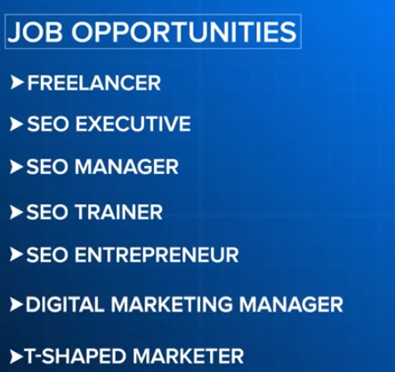

More than 50 percent business which work in SEO are making Indians work because labour is comparatively cheap and for them it is cheap and we get money in dollars o **Freelancing** is a very great opportunity In this course we will talk about freelancing when you are doing SEO then how you can make a career in freelancer apart from it

If you do jon then in starting you can do **SEO executive**. You can do job as an intern. There are many vacancy where you have to work under managers and they assign you task and you learnit also keep doing this and of you have promotion then you can become **SEO Manager** if you are in this fiels for long then you can apply for **delta SEO Manager(Who knows)** . You can become **SEO trainer**. You can go to Training part you can join WS Cube Tech if you are specialised in your field and make people learn it or you can launch your own course. Make your own website and do blogging or you can do **SEO Entrepreneur** . You can start your own business and make your website and do your own SEO. Now you know how to make your website reach people

You can become **Digital Marketing Manager** If you want to become Digital Marketer then you have to learn many think along with SEO like paid ads or Social Media hten you need to learn them to become a Digital Marketing Manager. You can become **T-shaped Marketer**

It is a digital Marketing term but here we are specialised only in one field but we have knowledge about other For example if you are specialised in SEO by taking knowledge of others you can become T shaped marketer Apart from it there are many opportunities

Even if we go to Linked in and we search SEO there

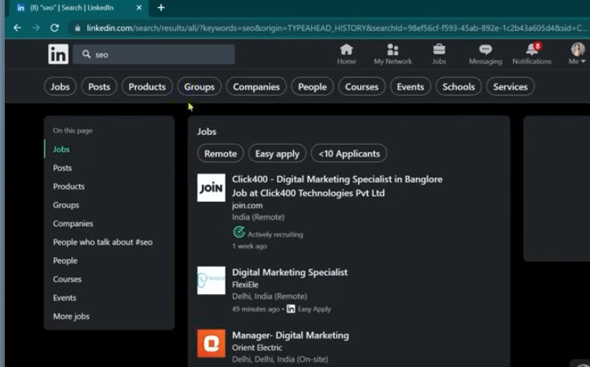

And then click on Jobs then here it will be shown

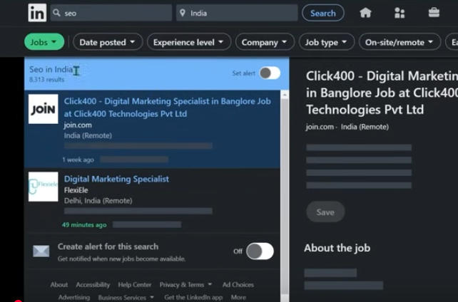

Many jobs here

Even if we talk about India only then there are 8000 jobs

If we choose remote jobs then

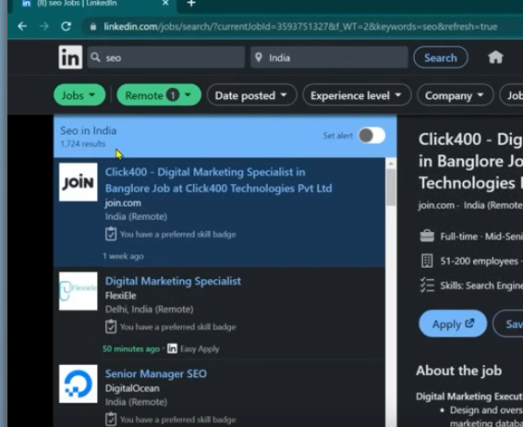

Then there are 1700 for now fro remote places in India (maybe)

Here we are talking about jobs here not about freelancing

If we go to fiver only then people are earning in lakhs online by doing SEO after learning SEO

These are the career opportunities you see there but obviously there should be expertise or practical knowledge so that you can work for anyone

**Lesson 4:-**

In this lesson we will learn about **Key skills you require to become a SEO specialist**

If you want to become an actual specialist then what are the skills you should have

Her are many myths are cleared Many people say you need to learn coding and some say you need to learn English Here teacher is going to clear everything The are the skills you need to work on

So first of all the most basic requirement is that you need to work on laptop or computer

It is mandatory. It is not hat you need to learn abcd of computer or every setting or everything but if you can know how to start dome basic laptop or Internet or open browser you are good to go

22:40

And other things we will learn in this course So just need to learn how to use laptop and learn to use Laptop

If no then go to your laptop and buy it and start practising

You should have **Internet knowledge** by that we don’t mean that you should know coding or development you should only know that if you want to search something then how to do it

How to use google How to open website if you know that then you are good to go you don’t need any other things

You should know about MS Office from basic. Here we are not talking about advance At least Excel or Ms Word PPt. You should know about it from basics It is not like to learn every formula By basic we mean someone say to make excel file , someone say to send Word file then you should know about MS Word What is MSPPT By PPt we mean presentation So you should know MS Office from Basic

Apart from this **critical thinking**

This is most important in course whatever we learn will be 50 percent of the part . Teacher can Teach us 50 percent but the type of project you will face the situation you need to work accordingly and for that you need to have critical thinking

You need to have power to think out of the box if this situation arises and we got stuck so what to do what are the necessary steps I need to do that called critical thinking. You should have a common sense which is nowadays is very uncommon because we cannot learn everything

Suppose Teacher taught us something lets suppose a project comes and the situation is very different then what you will do there There you need to use your common sense whatever we have learned now and the current situation How t correlate it

So if you have **critical thinking** and **common sense** then you can become a SEO expert

You should know **Basic English** By that we does not mean fluent English we mean suppose you have blog opened in front of you If you read it and a mail comes and you read it you should understand that what is written on it if you know that then you are good to go

Because in Google after every 15 days or 30 days an update come suppose you do the course and teacher has made us understood update till now but after 1 year new update came then industry will start working accordingly but you will not be able to read it teacher is taking an example So in that case you should know that you can tell the meaning what is written on it Apart from it you know how to read or write then you are not good to go.

If you want to use Copy paste or use AI then in that case you should know at least English

If you are dealing with international client then you need to know how to speak in English but basic English is sufficient If you want to move forward and know how to handle international client then you are good to go

And you should know **SEO Practical and Theory Concepts**

Practically you should know that if a project comes then you should know how to deal with it. What will be the first step and How to talk to client for that you should know Theory concept because if your Theory concept will be clear like you don’t even know what is SEO

What are its type, You don’t know about Keyword research so then how will the client understand. How you will convince the client So theory concept is important we need to know 10-20 percent Theory and you have to do the practical bring the results so that you should know about it

These are the skills you definitely should have if you want to be an SEO specialist Apart from it the skills you need are logical development , critical thinking development common sense development we will work through out the course

I hope after this course you will become an SEO expert

**Lesson 5:-**

In this lesson we will learn about **Search Engine**

Because we are learning Search Engine optimisation means you are learning How to drive a car and if we don’t know what is car then how will we drive it similarly if we are talking about search engine optimisation then we need to talk about search engine because if we understand it and its working then the work will be very easy

So **What is Search Engine?**

See when the search engine was not even discovered or launched if we talk about Google

Google became popular between 2000s but was launched in 1998

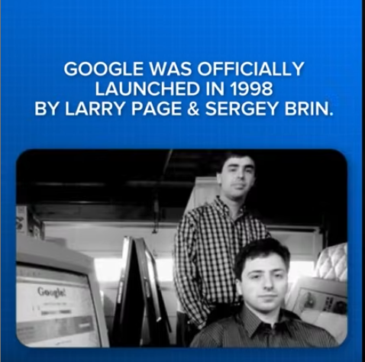

But internet existed even before this then how did they use internet and website was there before any search engine So previously there was only browser

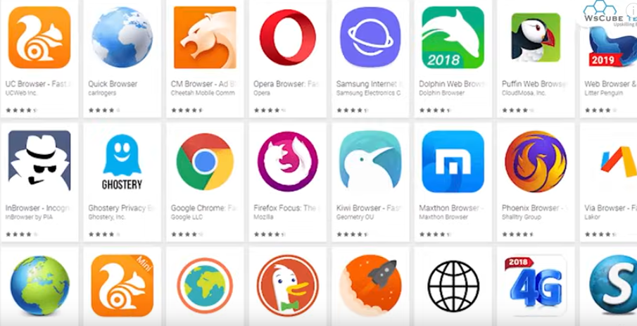

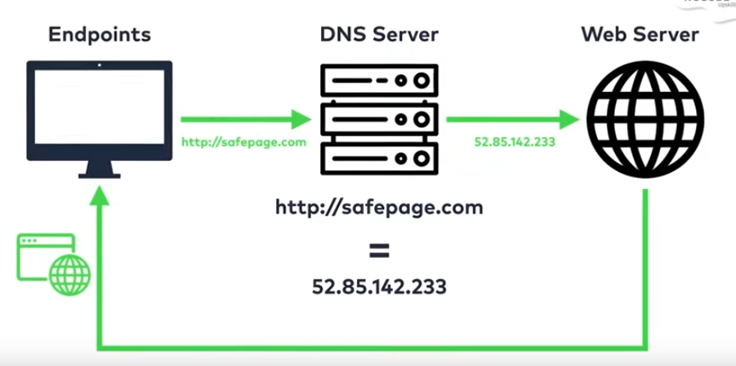

Browser work was that it get connected with server and whatever website you were putting whatever address you were putting or url were putting then that website were shown to you

But there was same problem that we had with mobiles that we need to learn each mobile number when there was no facility of saving mobile numbers So what we did was we need to learn every number whenever we cee dot call someone we need to dial that number

But now we have smartphones we don’t need to remember it we can feed multiple phone numbers and whatever name we search and we will get the whole directory so similar work was of search engine Previously we needed to learn every url if you want to open any page then you need to remember its url so it had become difficult to do.So in that case search engine was discovered so what search engine did that now you don’t have to remmber evry url . You just enter keyword or query and we eill tell you all mrelated content so that was the work of search engine If someoine ask you if there was no search engine what would have happened then if so then we have to remember url of every website that would have been very difficult for us

Then **What is Search Engine?**

A search engine is a software system or application or website that is designed to carry out web searches.

It s work is to search through the data present in the Internet

How it searched when you will give quesries to it when you put a word there then on the basis of these words it will give you result For example if we want to google

And searcg what is SEO

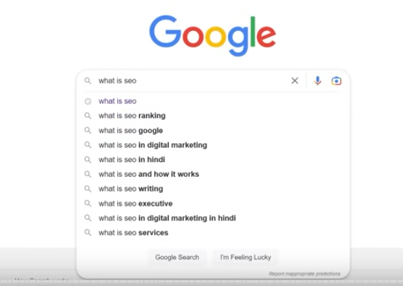

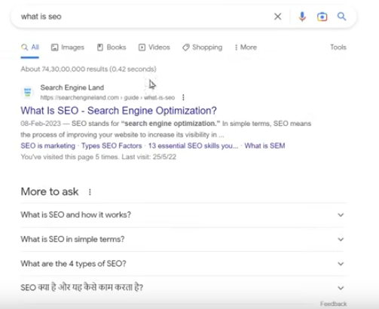

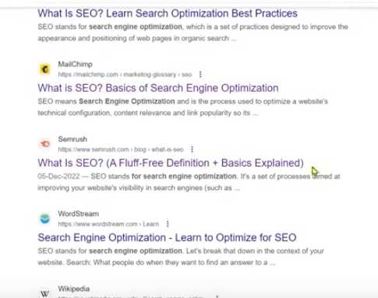

Then you can see many sites and we have approixiamtely results in millions So we put there (keyword in search engine )and whatever content is available in Internet should show it

Now we will open a website shown in the list and we can consume the data

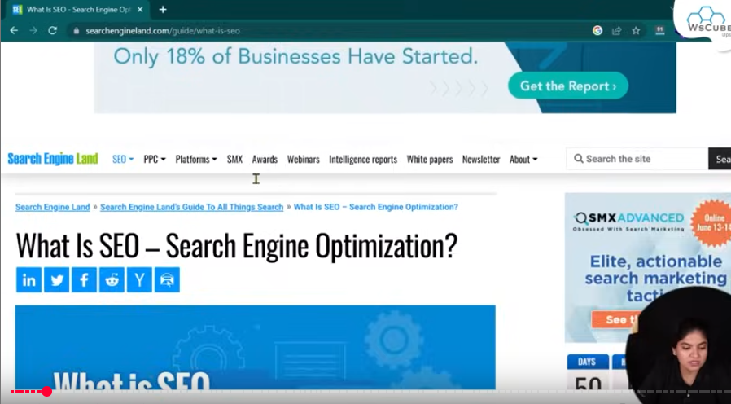

But if there was no search engine then if we want to visit this page then How would have we done it We would have learnt this url. Suppose this url got changed and we have done some small mistake in the writing of url whether it is one letter mistake then we would have page not found

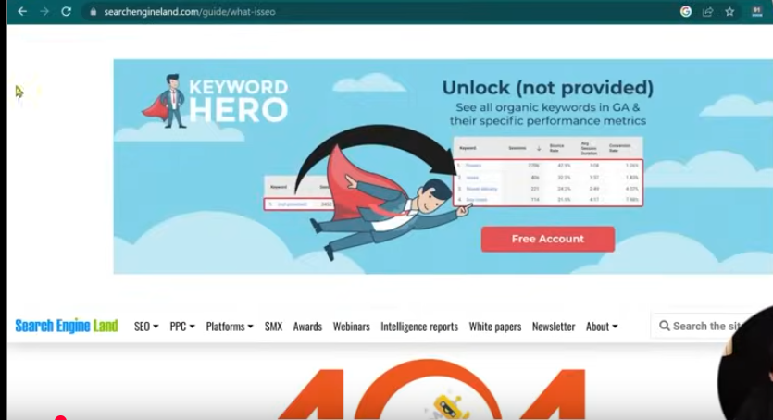

And we would have not reached that page and we would not have figured out that what we actually want to search

Suppose if we have done mistake in domain name then it would have shown below

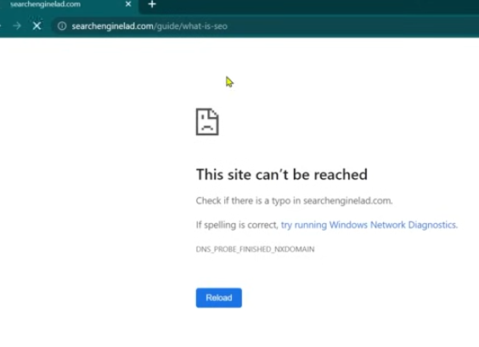  
that is site not found so we would have to learn that url as it is but we have search engine even if you write some mistake in typing the query

Even terhn you can reach correct result

Suppose we so a mistake in what is SEO

As shown below

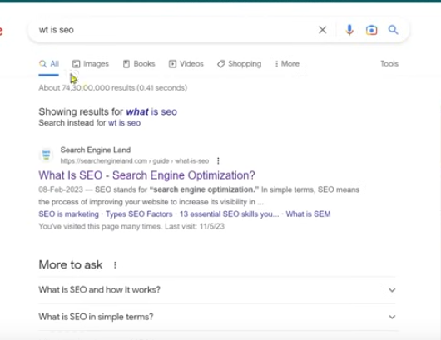

Then we will get result then this is the benefit of search engine

And search engine is a software system or application or website whose work is that whatever content is present in the Internet search on it and that’s why it is search engine

**Lesson 6:-**

In this lesson we will learn about **SERP** or

**S**=> Search

**E**=> engine

**R**=> result   
**P**=> page

and what is this for that we have to again go to Google so last we did see Search engine

so how search engine work. You enter any query then on the basis of that query or using that query it will give us result So what google did use this query and it will show all the data related to it in the Internet will be shown here

whatever it shown to us the website link or images

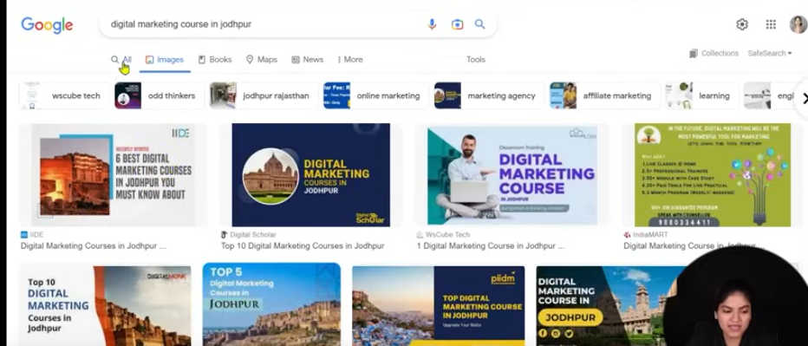

That’s called result Whenever you question someone you het answer similarly you get result here. So the result you are getting and the page it is on we call it SERP

You can try any query

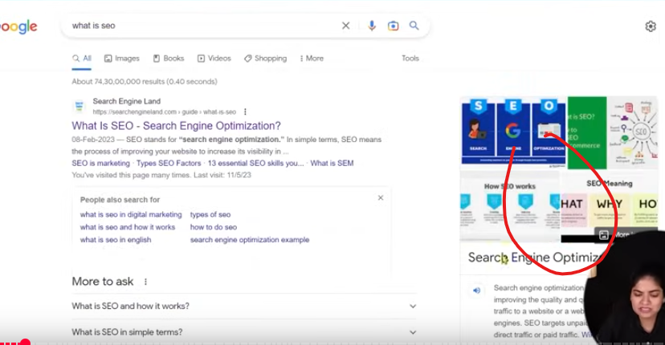

The marked one will be told by the teacher later

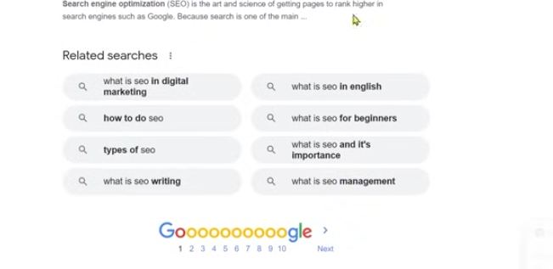

You can see la the related searches and pages and many images these are the result. The page we are in is SERP

If we talk about SERP in google when Google was new then it was very basic search engine result page you just see only blue link and there was small description you click on it and website get opened that’s it but gradually it has emerged mean with time it is evolve

Previously it was just result but now it has images also, books section is there, videos , shopping or more

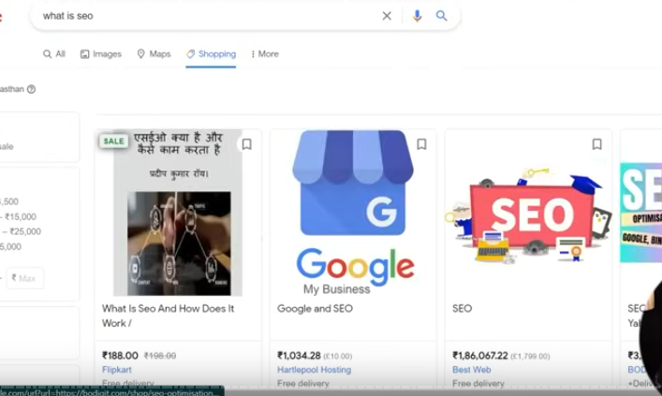

If you go to here then you can see the product if you see more then you can see

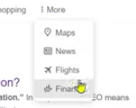

News.,Maps, Flight and Finance

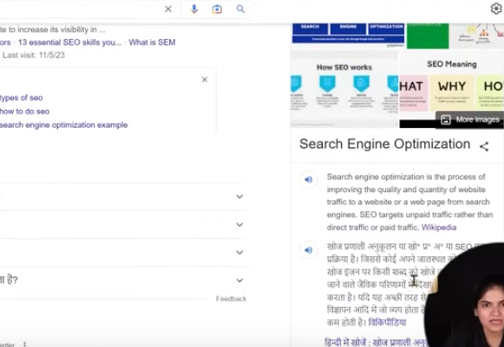

And with this it has extra information means we don’t even have to open any website if we just want that what is SEO and here are also images

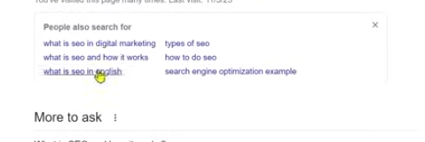

And you can also see section People also search here here are many option

And here there also

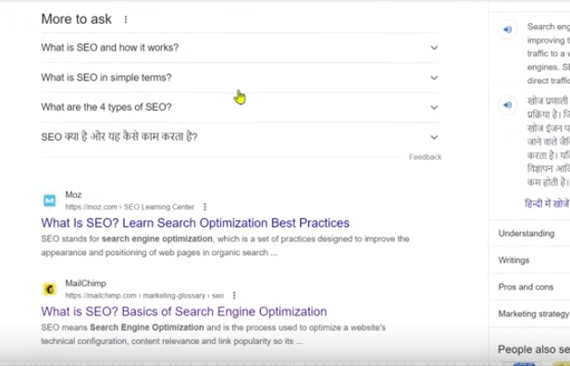

We have more to ask section as shown above These are the FAQ . you can also see related search at the bottom

If you search some business

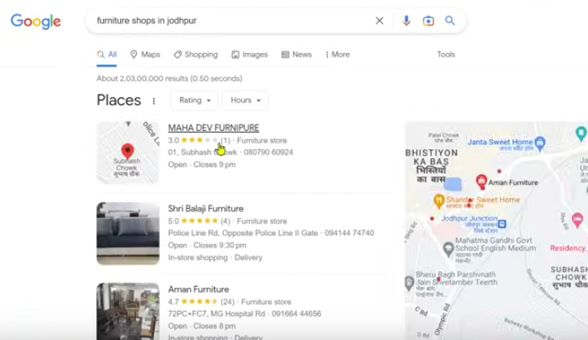

Then here you can see listing oof business which we call local business and you cn see website

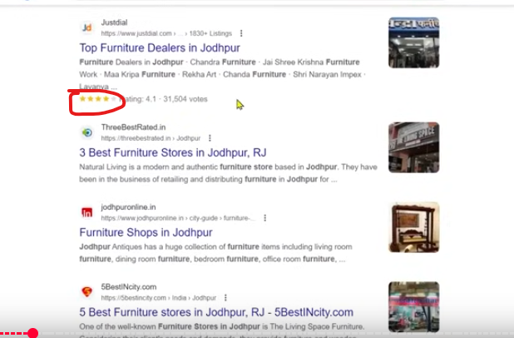

And with website you can see rating or there images

34:05

It means the SERP has become very advance so that’s why teacher is making us familiar with vocabulary so that you know these things that what is SERP

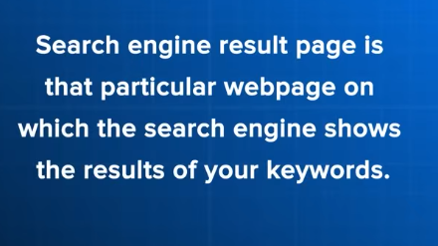

**Lesson 7:-**

In this lesson we will learn about top 10 search engines

When we think about search engine then google comes in our mind and why not because itself hold market share

But Google is not only search engine there are thousands or lakh of Search engine

So among them we will talk about top 10

They may come handy for you as well as so that you know that Google is not only search engine

If we talk about google then it holds more than 95 percent share in India and in world it is 92 percent

More than 150 plus countries Google is the top ranking search engine means more ans more people of that country use that search engine. Some country have there personal seach engine where Google is banned we will also talk about them

These top 10 are used the most

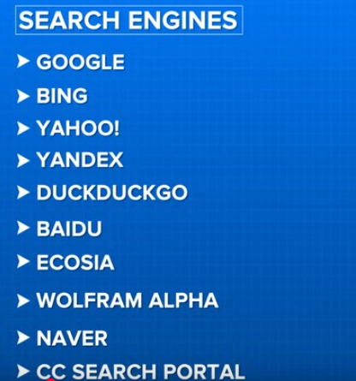

1st is **Google** the king of search engine

The google is such huge search engine and popular search engine that when we say search engine then we say google as we know it is search engine but sometime we call it google like we call toothpaste colgate sometimes similarly we replace search engine with google in our Vocabulary We will talk about it throughout the course

2nd is **Bing** which is a Microsoft search engine

Bing is used because when you take windows laptop then by default bing appears

You know the most search term in Search engine is Google means people are searching for google in Bing So Bing is also an important search engine

In upcoming lessons if we talk about we submit our site to the search engine then we will also talk about bing there

3rd is **Yahoo**

Yahoo is basically fathers of search engine because you can actually call the one of the oldest search engine but it may happen that it will get removed from the market in future

Because many website which were yahoo oriented like yahoo answers has been removed

4th is **Yandex**

It is Russia Search engine means 50 percent population of Russia use Yandex and other people use Yandex Google is not banned in Russia but it has its own search engine so people prefer this because every person loves there country

5th is **DuckDuckGo**

This search engine is for who love their privacy means if you want that whatever you are searching and your data should not be stored as we know google store our data and track it

So DuckDuckGo gives us 100 percent privacy It will not save your data. It will never track your search history and on that behalf will not show you ad

People who want privacy and they are possessive about their data then they use these

Mostly ethical hacker or cyber security expert use DuckDuckGo. It is also an emerging search engine

6th is **Baidu**

It is a Chinese Search engine Google is banned in search engine In chine Baidu is used More than 80 percent user use Baidu and other are other Chinese search engine

So Baidu is a good option if there is a client whose chine ais the targeted audience then make sure your website should be there

7th is **Ecosia**

It is a charity based search engine means whatever you search in Ecosia means whatever money earned by Ecosia will go to Ocean Cleaning By the way it is a google search engine easy to use because its interface is very simple

Try these search engine and definitely try

8th is **WOLFRAM ALPHA**

This search engine is emerging very rapidly and teacher has seen many people using it

Here ads are not seen in Browser and here you can search category wise If you search in google then you can see any category type of content but here Categories are made that whether you want education content, Technical wise , Entertainment wise you can choose

9th is **Naver**

It is South Korean Search Engine in Korean Language. If you know South Korean then only you can use it Techer thinks that its English version is also available South Korean audience mostly use this

10th is **CC Seach Portal**

It picks up data from all search engine but its special thing is that whatever you search here and whatever you get here will be copyrighted means you can use there content freely there will be no copyright on you Many people like this

If you are copyrighter then you can get many inspiration

These are the 10search engine that you can explore It can happen that Baidu will not work on your computer but you can try By that you know that Google is not the only search engine there are others

Mainly when we talk about SEO then we talk about Google because once your website get ranked by Google then it will be ranked in other search engine on same keyword

May there all internal mechanism are same

Just think you need to do promotion in two places one where it is only your 5 percent audience and we are not clear that these 5 percent are our audience or not

Obviously you will use it in 95 percent audience. The logic is very simple that’s why whatever updates or Technical thing we will see on the basis of Google and if get ranked in googler then it will be ranked in other search engine also

**Lesson 8:-**

In this lesson we will learn about that the search engine which we are optimising our site for

**How does a search engine work?**

Because Teacher always say that if you understand that what is the working of search engine then to understand SEO become easy for you so understand this lesson clearly and don’t miss any step

Now imagine you are in Restaurant and you order Pizza that you want Pizza. If someone make Pizza from scratch(managine ingridient (maybe)) then he take 2 hours but when you order pizza then it takes only 5 seconds that there will be Pizza on the Table. What it means they go and make pizza in 5 minutes no It means they had done preparation beforehand

If we talk about search engine then whatever you search in search engine then in seconds you get your million of result How It is possible It is an obvious thing that here also search engine has done its preparation Yes whenever you add query in Google then Google already has founded the data of that query beforehand but how it knows you need that query soi for that you need to understand the working of search engine where you will understand step by step that How a Search engine work

SO first of al Teacher told us about Website How a website is formed and How it get uploaded When a website is made then it is a documentation saved in your computer

Any developer make a website3 then he make it in his Laptop in LocalHost then what you do is making them live means making them connected to Internet or putting in Internet or putting in Server Now all these document or resources are now connected to Internet You need to understand this first

Now we will talk about **working of Search Engine** The first step in the working of Search engine is

**Crawling:-**

By crawling we mean search engine robot or you can see it as a worker of Search engine we can call it crawler or spider It come in our website and ten read the source code and store it in its local server

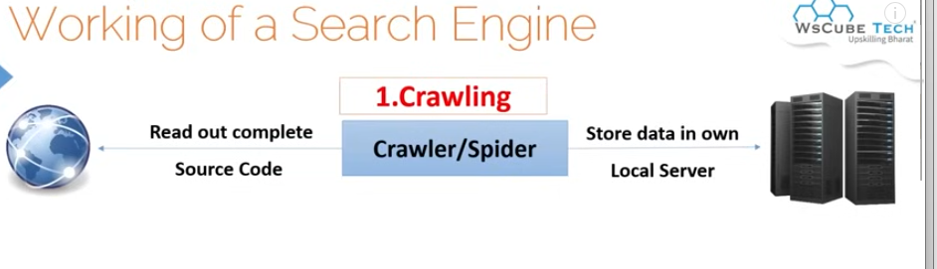

Now Teacher will tell us how the source code look like

Now you open a website and then press the shortcut key Ctrl + u

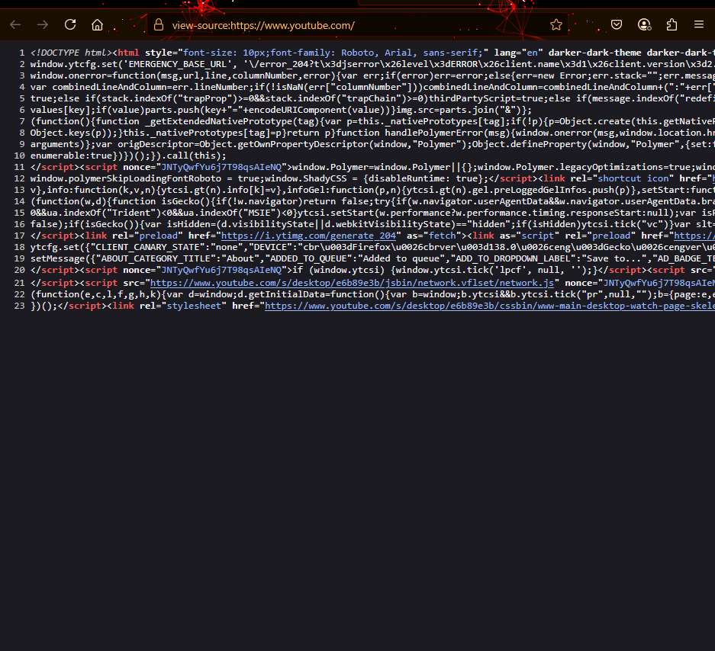

This is the source code of Youtube

Youn can call it source code or structure of your website or your website SGML

Crawler read this By reading this it keep it in local server

Here search engine don’r give a shit tha your website is related to Entertainment ,technology , food etc He just read this and assume stored it in its pendrive

By local server we mean Google own Database

We call this thing **Crawling**

As new websites are emerging in Internet getting uploaded in Internet getting connected to Internet

Google crawler go there and crawl those website and read it and saving it in its local server and creating its own database

Apart from it if you have old website then he crawl it again and again because it may happen that there is an update if you are doing changes in your website then it is crawling even you can call crawler yourself and say it crawl your website and read it and take it with them How do we do it we will see it later

By crawling we mean reading of your data by reading your source code and your every webpage and take it with it and saving it in its local server

Next step comes in indexing

By indexing we mean to dividing into categories

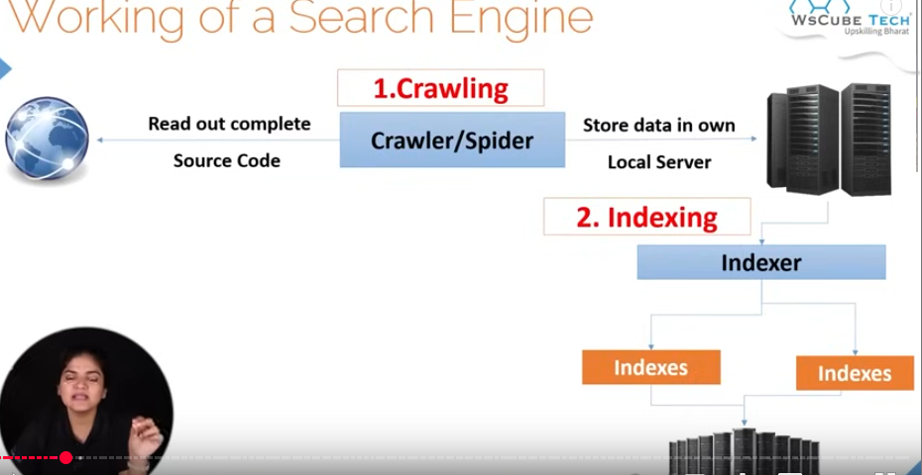

In indexing what google is doing is that these indexers ( another robot of google ) Its work is that whatever data has been crawled by crawler which it has saved in it local server categorize it into different categories means dividing it into different categories or indexes

Now there is so much data. Which web site is of Technology and inside it what website is of Digital Marketing sub category and inside it what are of SEO category and inside SEO it is of on page sub category by this way doing categorization of it.

46:55

Now If try to visualize now we have thousands and millions of categories and inside that category there are thousands of pages because Internet have lots of website and have lots of webpages

So google is crawling them and indexer is categorizing it . It can happen that one page is in multiople category

Suppose if there is a page in which there is a black woman dress uploaded of zara

Google crawler came and indexer will index it suppose if there is women category clothing then inside it this page will go. In women dresses this page will go. In black dresses this page will go . It will also go in Zara category

So one page can belong to 1000 of category so there aree 1000 of categories Spo this is the step which we called indexing

First is crawling that is reading the data and saving it in the server and the data in that server weas categorized by the indexer Now how it categorized it by seeing what is wriiten on the website

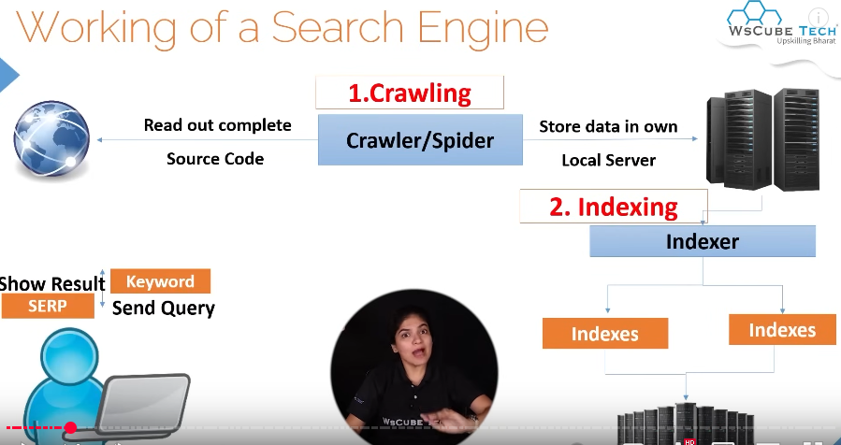

Now comes the work of user

Now you type any keyword

Suppose you type black dress for party

Now google will give us result

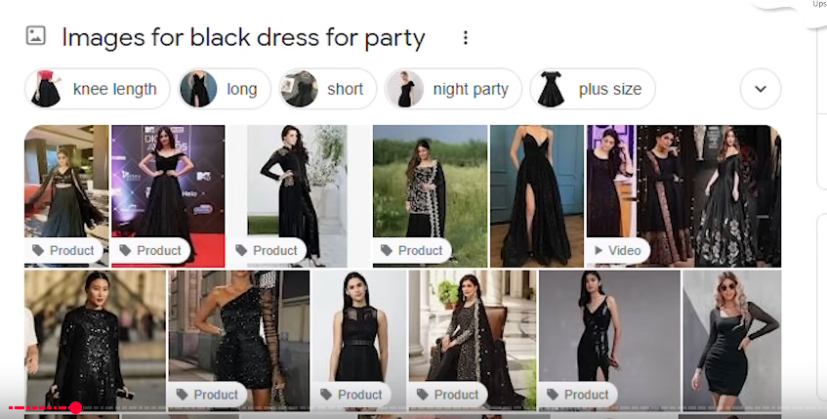

How result it will show on the basis of categories it made

By summing up those categories it will show you only that category meaning black dress category

Means inside one category there are thousand and lakh of pages it will not happen that it will throw all the pages

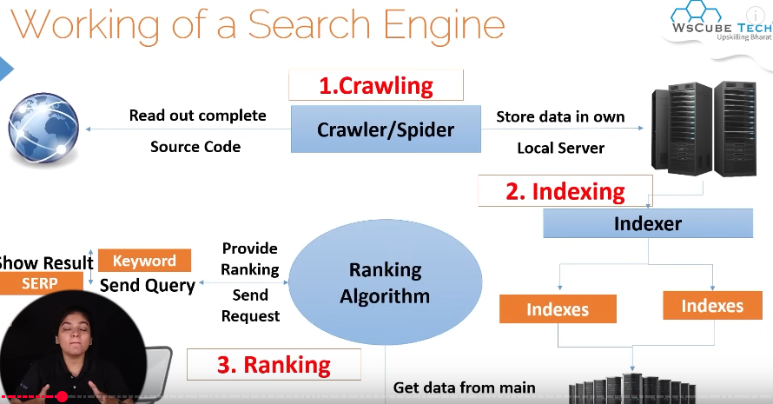

It will give proper it in proper ranking

Mean in 1st there are another result and in 2nd there is someone else ,and so on

By that way whatever pages are in that category are ranked

To decide this ranking Google use its complex and difficult to understand ranking algorithm

By ranking we mean complex way or calculation that it will use it and the pages or the category it is giving you and the pages in it will be given rank here

So the working of search engine I divide into three steps

1. Crawling
2. Indexing => Dividing multiple data and pages
3. Ranking

Now understand that in one category there are one million web page and there is category which have 100 web pages

If we talk about both of them then what you will want. Your web page will be in what category by the way it goes to both the categories but which has higher ranking chances will be 100 because in 100 there will be less competition there are more chances to come at top there but in on million there are more competition To rank in one million we have to do vary much hardwork but special think about 1 million is that more and more people are searching about it that’s why there is so much content here. Well we will talk about it later but if we talk about the working of the search engine

That is crawling, Indexing, and Ranking

Lets understand it by an example

Lets suppose you have a library

And there are three peon or worker

You say to 1st worker that go to market and whatever new magazine, books bring it to me

So first person go to market and then whatever updated(revision) and new books and new newspaper are present in the market bring it to us He don’t mind whether this book is of English , literature , novel What we said to him to bring new books and then bring it to us

This first worker in context of search engine will be **Crawler**

Now comes the second worker we say it to him that this first peon bring so many books you bring the books and put them in different category shelfs you can say categories that are formed so he pick up each book and see OH it is Hindi novel then we need to put it in hindi shelf In hindi if there is a section of novel I need to put it there. If it is in Urdu then we need to categorize it . This is in English and it is comedy so put it in its respective shelf So those multiple shelf formed in the library the second peon is putting there the books related to that category

Now this second person is **Indexer**. Its work is to do indexing and categorizing it. Next person that is our third peon

His work start when there is customer comes in the library and says to me that I want this book

Now we say this third person that go and the category the customer is demanding bring those books related to it Then he will go there and in that shelf In which there are 1000 of books he will bring the best 5, 7 or 8 books and 1st book will be best , 2nd book will be better than 3rd and so on\. On the basis of relevancy he will show the books to them

So this third person is **Ranking algorithm** because it is giving us books in proper sequences to the customer

If you understand it then of course to learn SEO it becomes easy

Now the question comes that when we will do SEO then what are the things that we need to focus on teacher always so

That a Good SEO expert

Will work on both of these things that is crawling, Indexing and ranking he does not focus only on ranking So he will focus on all of them

Because from there you must have understood that

Lets say your website crawling was not done better So does the indexing be good .If the indexing is not proper then how will be ranking possible

In this full course of SEO we will talk about three of the factors.

**Lesson 9:-**

In this lesson we will learn about **Google Major Ranking Factors**

We will talk about whenever we talk about SEO then what are the factors that Google or a Search Engine considers it wile ranking your website

By the way teacher has told us that there are more than 200 + factors when ranking of your website ranking is decided

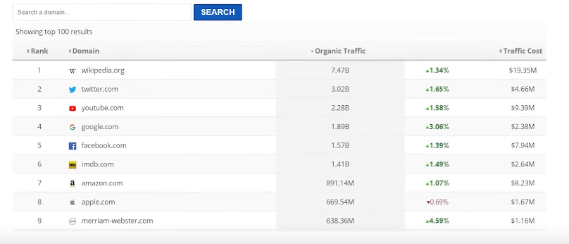

If you have studied precious lesson then you might know that in working of Search Engine there are three things in it as shown below

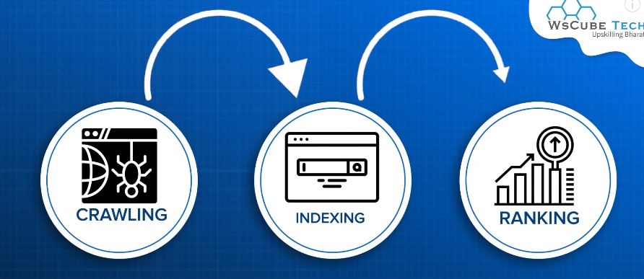

To decide ranking Google applies very critical algorithm and apply complex algorithm so we will talk about it that what are those formula by the formula there are more than 200 factors

To understand all of them pointwise it is not possible.

So we will talk about **major ranking factors.** Some factors are in our control measn through SEO we can optimise it or bring changes or improve our website. But some are not in my hand. So basically Teacher has tried to sum up all ranking factors in some point. So whatever ranking factor is there Teacher has tried to some up but apart from it we will consider some factor. So first of all in Todays time which people are taking lightly that is **High Quality Human Content** which is our first point



Here two words are used

First is **High quality**

By High quality we mean first that is not duplicated It should be not like that from other website you picked up the content and paste it in your website No never ever do it

It is just a small investment your website is in making take it as your home is in making or office is in making. So will you do save money there due to which you think that whole house or office can collapse you will never do these things then you make website then why you do this. Taking content from anywhere . Make it write from others. No take your time because this is a one time thing. Whenever you are putting some content whether it your Home page description, About Page description or Contact us page content.

Make it write from a professionals you have to at most pay 1000 or 2000 rupee per page. We are talking about good quality here. It can happen that you will get in budget and give you High quality content. Just do one investment and good quality should be on your page.

Check the **plagiarism** which will see later how to check it By plagiarism we mean there should be no copied content

Second is **Keyword density** It should be not like that the keyword on which we want to rank on should be mentioned there.

Apart from it we need to make sure that content should not be AI generated

Second word is **Human content** By this we mean Human written content. Google is saying it in all updates that AI content will not work. If there is AI content then your website will be treated as a spam. And the website will be downrun or will be blacklisted

So we need to keep the human content or Human written content not AI based content

Now later we see how to check it



Now comes the second point that is **Relevant content** whatever is your niche like if we talk about Digital marketing related website then make sure that the content should be relevant to the topic the website is made for

It should be not like that new thing comes in the market and we keep the same content no

By this way your niche become distributed Google could not understand that what ius the genre or field

57:00

so relevant content content should be there apart from it

third point



We will talk about it later that what is this

Page speed which means How much it is taking to load you page because no one loves a slow website

Think yourself that most irritating about website is its slow speed that you cannot use due to which the user experience will be worse and if the user experience is not better then why he will spend more on your website then google will think that you did not like their website

SO your core web vitals should be strong and should be passed (who knows) and web page speed should be fast we will talk about it lkate that how to increase the speed and how to check it.



The 4th point is **Domain Age**

These are the think which are not in our control that how much your domain Is old

Instead its effect is 1 percent it still effect out ranking

Because even in home the small childerend are listened late How much he is giving good advice but the big people of home are heard more

The same thing Google done partiality here SO domain age is a small factor It is not like if your domain age is old then your site will definitely rank

It is just assume that it is 0.10 percent factor

Now comes 5th point



That is **Network of Website** by that we mean how much internal and external link are there and how much backlinks are there

6th point that is



**Social signal**

It means how much you are famous in your social media. How much you are strong in Social media .If social signals are good coming to Google then your website will rank . Let suppose there is a operson he has account in Instagram. For example there is an influencer and he has 2-3 million followers and he post many things and interact with many people and has good fan following. Suppose he kaunch a website in his name then do you think he need SEO too much. People will come there through Social media and give that much traffic due toi which google have to give ranking reason being because his social signals are good and people went to view this so google will rank

7th point is **Keyword Prominance**

You website important parts should have keywords Now when we will do SEO with time How you can put keywords there we will understand it Apart from it there was an update in Google that is EEAT

It meanings are:-

**E =>** Experience

**E=>** Expertise

**A=>**Authoritiveness

**T=>** Trustwordiness

If in your website four points are covered

In your website **experience** is being shown , expertise is being shown that you are an expert on whatever you are writing or providing second you have **authority** For example if there are money related website or money related blogs., finance related blogs, websites For then that algorithm is very important that your Authority that who you are to give Social advice or give health related advice. You have to prove it. How you will prove it we will talk about it later Now come the **Trustworthiness** that your website is secured or not. Suppose you are talking transaction from someone then that network is secure or not. These things are also seen. SSL certificate comes in Trustworthiness that SSL is required Google is repeating itself that SSL certificate is a must. Next is **mobile optimisation**



In todays time more than 50 percent of traffic comes from mobile. People are using mobile. If your website is compatible in desktop but in mobile then why will google rank it so that’s why mobile optimisation is important for that we use AMPs (Adksp(I don’t know) mobile pages) that we will understand later

9th point is **Website Security**



Website security is very important as the Teacher has said that SSL is very important . website should not be hacked. There should be no thread, virus on website. These things are also important

These are some factors but it is not like that these are the only factor

There are many other factor that we will study

In this whole SEO course whatever we will study that will we do for ranking So these are our ranking factor Apart from it that your website crawlabilty should be good. Your website indexing should be proper. Ther should be more broken list there

With this there should be schema markup in your website due to which when it will be shown in the search engine then good rich snippet is created (who knows)

Your performance should be good in social website. These are our ranking factor

**Seo Vocabulary**

**Lesson 10:-**

In this lesson we will learn about **Black Hat & White Hat?technique of SEO**

SO here we will talk about **technique of SEO**

See whenever we choose some work to do then there are two ways one is right and another is wrong

If you want to earn money one will be right way and another way will be ethically wrong way

Similarly when you do SEO then there are two major way to do it

Again right or wrong way

To influence out ranking in Google then starting method will be that you write good content and work on your website that google has given guidelines follow them means you are using the right way

Such way we called **white Hat SEO**



So the meaning of White SEO is that by following Google guidelines when we do SEO that google has given us some guidelines that you need to write **good content**



And keep the **website speed good**



And the keyword you use it should be relevant



With this the backlinks we are going to use should not be fake Not to buy backlinks. You need to have good social media reputation some things are prohibited and some things are told that we need to do this if you want good ranking So when we follow this guidelines then we say it is White Hat SEO

And on the other hand we are doing SEO and going against the guidelines of Google then we are actually doing Black Hat SEO which means wrong way of doing SEO Do here we are not following Google’s guidelines and what we are said we are not doing it but what we are prohibited we are doing it we call it Black Hat SEO

Examples of White Hat SEO will be

To enter good kjeywords , upload quality content , impeove ORM of our website , improving PR of website. Doing on page properly and correcting technical things of the website So whatever

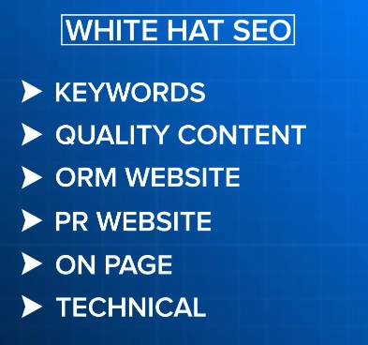

things we are studying in this course will be white hat SEO

and thee are things that come in Black Hat SEO

like **keyword Stuffing** SEO. That is Repeating that keyword again and again in your content.

Adding **Hidden text or Links**

Using **Doorway pages** means the pages used for showing to the client are different but where he is landing are different you are making it index(who knows)

With this doing **cloaking**

Doing **overOptimsation**

Make Fake BackLinks buying backlinks that google has strictly prohitbited

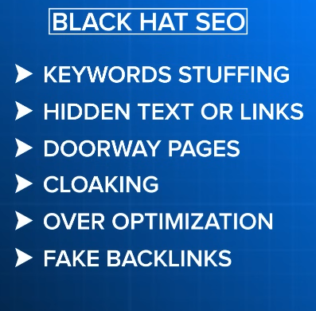

So these are the things that we call black Hat SEO

So when we do SEO then do White Hat SEO and don’t do SEO

The reason is that Black Hat SEO is a spamming technique due to which google put your website in spam instead of ranking of your website being increased it decreased as well as your website could be blacklisted

By blacklisting we mean google remove your website from its indexing you would not want this but still some people use this technique and the reason is that by black hat website often get ranked fast and get fast push but for short term

So such website which we want that for some push like 2 or 3 month our website get ranked and if it get deleted then we don’t mind it so those industries use black hat SEO but if we talk about Industries then in Industry Grey hat SEO is done most of the times.

**Lesson 11:-**

In this lesson we will learn about **Grey Hat SEO?**

And is it really it is used or not



Means after applying White Hat SEO in our website or after modifying your website for good thing by following the guidekines of Google



We take some percentage for Black Hat SEO . So we call it grey hat SEO. It is often said that mostly industries practically they do grey hat SEO and it is to say to good extent grwy hat is used in Industries

Now why did this happen suppose we put quality content in our website. To say we are optimising its speed. Trying to give good user experience but due to high competition our website does not reach to correct people

So in such case if one person do some such activity that teacher will give us some hint throughout the course. Here you can use grey Hat Technique We will also learn it

Some for some percentage we do a grey hat ad then we get boost to our website like in our source code there are some spaces where if you put some extra keyword then user experience will not be affected but your website will get push in ranking in relevant keyword ranking So these are the technique we do

Apart from it It becomes difficult to differentiate between Black Hat and grey Hat SEO

1:07:55

So when you with experience and practically do work on lit of project then you will gradually understand that yes that grey hat mean black hat is that percentage Now I am going to totally on black that should stop So to know this difference will come with experience

SO initially doing SEO or it is especially new website then like Teacher has taught about

Sandbox effect



If your website is in sand box effect which means google is understanding your website then in that case do 100 percent do white hat hacking if you are learning SEO and it is your beginning then you ned to complete white SEO but later when your experience wi and with time you will learn something so in that case you can apply Grey hat SEO

So yes that is true grey hat SEO is used and its meaning is that after working on complete website we do something of black hat SEO . Is main thumb rule is that **user experience should not be compromised**



Whatever things that are directly effecting user experience like **content**



,**Website speed**



**Spam**



**Website security**



You need to focus on these things and make user experience better

If you keep the user experience better and you do 1 percent only black hat SEO then there will be no effect on the website but again teacher is saying that these experience comes with experience and work on many projects then you will be able to apply it

**Lesson 12:-**

In this lesson we will learn about in **Page and Off page SEO**



Whenever we do SEO you can call it stages or categories



Whenver we do SEO of website then we do in two parts

First is **OnPage**

And second is **OffPage**



But today we will rapidly or smartly understand in detail that what is onPage and OffPage

Suppose your website is a house and you are working on it.

Painting it and adding a furniture on it adding lightings on it adding water connections So whatever work you are doing on your home. Adding grasses on your home. Adding gates , improving security These things are the thigs that you have done work on your house

Now you have made your house. Now you want that they should come in your house to live then what you do is call them that please come and live there . Go to every place and tell about your Home that we have made a house. Come to that house The work you have done on your house we call it on Page SEO . Meaning our website which is like our home So whatever we are working on our website increasing its speed. Adding Keywords on our website. Improving its content, doing some technical pages

So whatever you have son eon your website we call it on Page SEO but we don’t do this only we do our website promotion on different platform whether we talk about Social Media or id we talk about another website that you come out of your website and when they do the promotion we call it off page SEO

So first we talk about on Page SEO

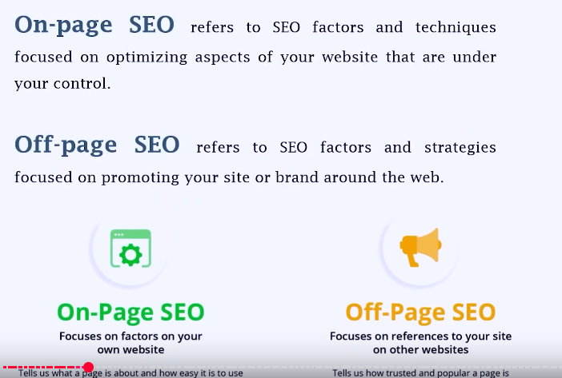

It means working on your website and their different factors that you do on your website

Improving content on your website and do technical change sin your website improving its speed and improving the security and many more things we call it on Page SEO

And off page SEO mean that strategies or factors that is you are doing promotion on the Internet

Usually suppose a project come so for starting we will focus on page of that because if the website is not working internally then you do promotion and people are coming then they still will not get good experience

So first we work on on-Page. Similarly we can work on off Page SEO and you can also do it after onPage then it will still work

When our team is big then we can do both concurrently and complete it in 10-15 days

SO when we are promoting our website in different website

There is a practise that we call link building where we make backlinks

By backlink we mean pasting your link on different website that person should come in our website and another is social media promotion

We make social media account related to our website and we are doing promotion , youtube promotion So this is our off page SEO So for our website off page or on page both are important .

There are some client that theie website looks good and we don’t have to do onpage on it. If there is then we have to small changes but they come to Teacher to do off Page SEO It could happen you can get those projects. Similarly we could other type of project that there is client who says he will see the offpage. Our promotion is keep going on we will see it so do its onPage So both way you can do the project

**Lesson 13:-**

In this lesson we will learn about Technical SEO

If we see it then it is part of on Page SEO

In many countries or we may say that for many people there are three types of SEO that is Technical, OnPage and Off Page.

Otherwise for 70 percent (or mostly) consider on and off page and Teacher also believe in it

And this Technical SEO is a part of On Page SEO

Its meaning is That the technical element of our website. Those elements that are the tech part of our website in which we keep our website structure , coding and interface of our website which is mostly done from developer end we focus on it

It is done mostly because so that our website can crawl our website in a better way and they can index I in a better way For these two ways technical SEO is done

When we understood the working of Search Engine then teacher told us that ther are three steps in working of it that is

Crawling

Indexing

Ranking

You are focusing on ranking and then you come to know that our website was not crawled properly .

When Crawling is not done properly then indexing will not be proper. If there is no proper indexing then the ranking will not be good So that’s why it is important to focus on Crawling and Indexing is very important and whatever we will learn about Technical SEO amoing them mostly exist so that our website crawling and indexing can be improved

The Page which is rendered by search engine can be done properly

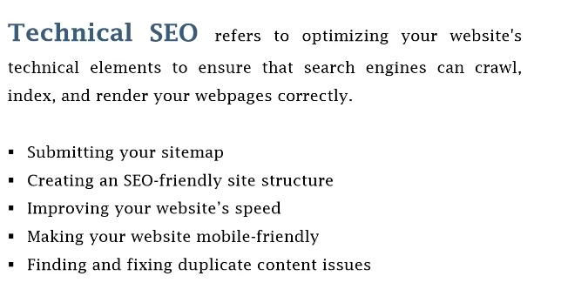

Inside this we will create sitemap and improving the structure, speed of your website . make our website mobile friendly with this we will improve and also improve content issues and many things we will do in Technical SEO

When it will be started then in every lesson teacher will tell that this is Technical part and you will understand these things Technical SEO is such thing that we don’t have to do in every part . If there is requirement then we will do it but onpage non technical part woll eb same as it is but our Technical part does not means that it will be implemented in every website.If there is requirement then it will work that’s why when we will study it topic wise then you can more clearly understood that what is technical SEO. So it means optimising those factors that are very technical that effect our in website crawling and indexing

**Lesson 14:-**

In this lesson we will learn about **Dwell Time**



Now what is dwell time we will understand that and how can you increase it we will learn about it So first of all if we talk about dwell time

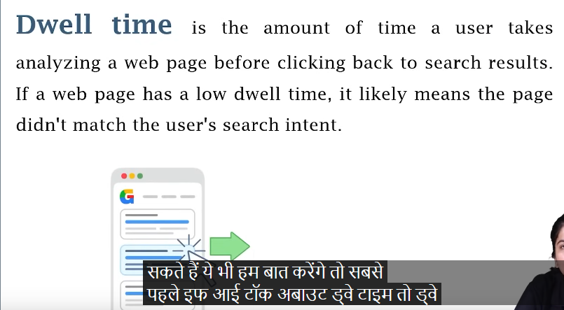

It means when one user come in our website suppose he come through our search engine Suppose he types some keyword and he came to our website and stays in one page whether there is 10 page visit or 1 page visit It does not matter. He entered in our website. After entering How much time he did stay in our website and after that go to SERP that is Search engine result page . The time he did spent in the website we call it dwell time

So you can see below

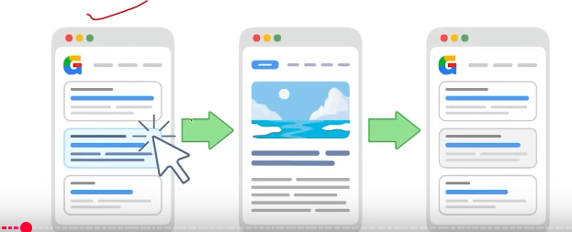

That first of all in our search engine web page website was shown and from there user click on these website and come to our website and suppose he spent 10 minutes there and after that he come back to SERP whether he went to see other page on the SERP(maybe) or he go out of Search Engine. It does not matter

Whatever time he has spent on our website we call it our dwell time

Now why we are talking about dwell time see if dwell time of your website is very less. It is clearly an indication that user come in your website but he does not get the desired content or product or desired website





It means that the intention for what the user come in your website or in web page. His intention was not completed and it can bring negative effect on your ranking.

1:18:00

If your dweel time is low lets suppose in your blogging website . This dwwll tiem is specially considered in blog time. Suppose a person types an informational keyword(maybe type of keyword) like how to make a chocolate cake and he comes in your page and he ses this content is not that useful within 5-6 second her came back to SERP or other page and see other result but he spend enough time there and see all the recipe so ggole get the indication that the first result google get the time her spect was just 5-6 second htebn he came back after it and he has to see the second search result. This means that in first time the content was not good and not relevant or the quality was not good so these things clear the dwell time



Make sure it should be high and the customer should stay in your website that’s why when we talk about SEO friendly content



We first talk about quality content

And then the keyword you are using exactly relevant your content should be

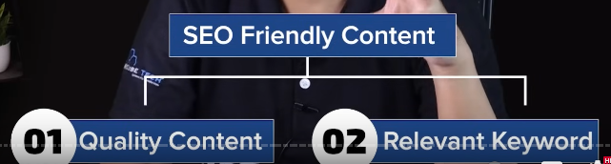

Suppose it is written How to make a chocolate cake . You have made the title of your link in SERP and when he come in your page by clicking on it

And he sees it is shopping website and your selling mixes of a cake

So obviously you did not fulfil there intention so User will immediately go back and by this you will also know that by your content his query did not get satisfied that’s why he had to go to other results So make sure your dwell time should be high for that you and for that you use high quality content,Use relevant content and more use

By the way there is no such limit that your content should be of a particular limit but hehter you have a business site, bloging or service based website or ecommerce website then make sure that it should have good content



There should be at least 600-700 words in your website or webpage whether it is of any particular niche

In blogging you can write more than this but write content of high quality and more

So make sure of this when you do this off course your dwell time will increase and with that is your page load time is more then it may happen that before page get loaded the user get out

So dwell time of few seconds is not a good thing

So dwell time is a direct ranking a factor it is very important to focus on this

**Lesson 15:-**

In this lesson we will learn about **Bounce Rate**

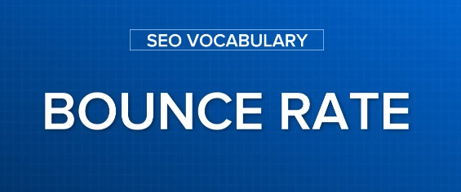

It is that thing that we everyone fear from it

Basically everyone who is learning SEO they know that is Bounce Rate

Now what is Bounce rate and Teacher will also tell that it is a direct ranking factor



What is the bound rate of your website it directly effects your ranking

By Bounce rate we mean suppose there is a website and user enters our website and when user came and whatever page user enters we did not take any action nether user go to any other page of the website neither we clicked on any button or any form or button and without taking any action user go out of the website or close the website or come back to SERP this is bounce rate

Suppose 100 people come in our website and out of them only 10 people do the things we discussed that is go back without taking anu action

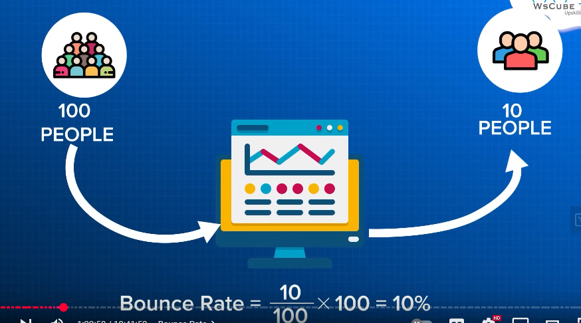then your bounce rate would be 10 percent

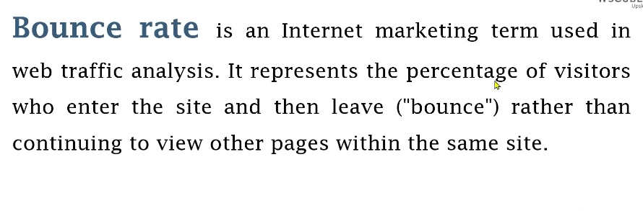

It represent the percentage of visitors who enter the site and then leave(“ bounce”) rather than continuing to view other pages within the same site Now the question arises that if there is one page website then what then there might be some interaction page or scrolling page or of there is some contact information so without doing any activity someone go there

Without going to another page then it is counted as a bounce rate like the Teacher told that

Bounce rate is a ranking factor

Now what are the ways to reduce it So most cheapest effective way is to make sure that on your page in stating there should be clickable elements



By which when a user enter your website then for example you have posted recipe of chocolate recipe on your page so make sure instarting you have some option like if you wean to see recipe of Vanilla cake or Pinapple cake recipe or you want to see recipe of without any egg then you have these option Suppose there is a person who say that recipe includes egg and we don’t eat egg then he get direct option that actually we are using egg but if you want an eggless recipe then here is the button so you put internal link there any person when wil click on it he will go that page and your bounce rate for that person will be 0 means he could not bounce

If one page person sees and from there go to another page and ten he become out then it will not be included in Bounce rate

Whenever Bounce rate will be calculated by **Google search console**(who knows) then in that case he will not count him

So this is our Bounce rate



Now with this use internal links you can improve navigation of your website

You can decide navigation of your website by ehich when one person come in your page hten he will visit another page

For example

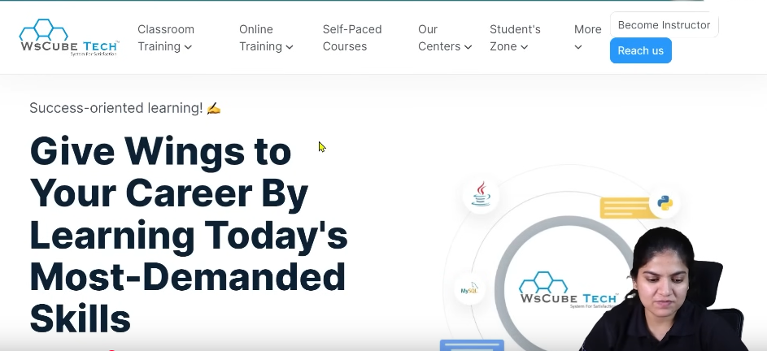

The above is Teacher’s website

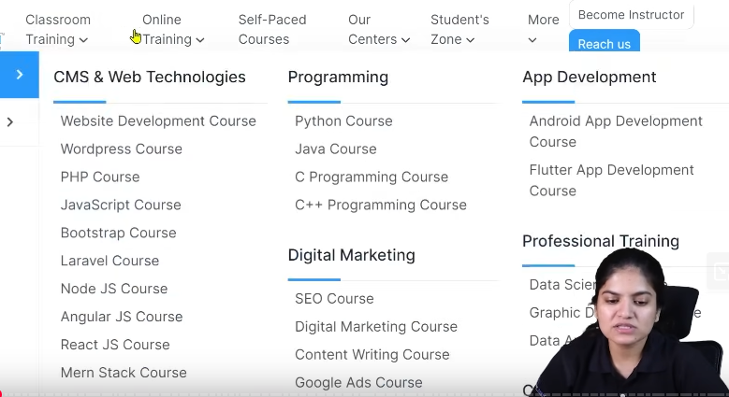

Now if you havoer over the manu then you will there are so many option to click

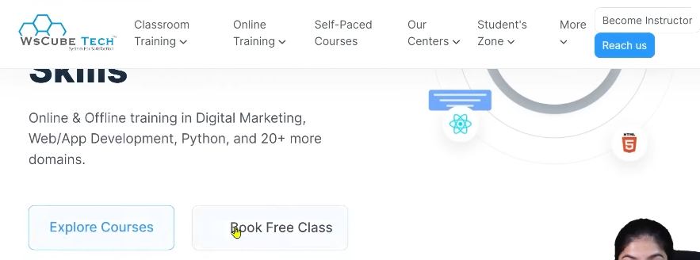

You can see buttons like Explore courses , Reach us , Become Instructoe

Means in the first page we have not even explored 10 percent of the page

We can see many clickable elements If we click on any of them then go to other page hten obviously as user will not be included I the Bounce rate

So you could try these things you have to make or design your page like this

So that you have more and more clickable elements ,more and more other pages where people will go

If you do this then the person will come and will click on at least one page

And that person will not be included in bounce rate then automatically our bounce rate will be decreased not just home page but also on every page you can use your internal links , your links under proper header , footer and also clickable elements so that your bounce rate will be reduced and your ranking will become better

**Lesson 16:-**

In this lesson we will learn about **Click Through Rate C.T.R**



Now what does it mean. Whenever we talk about leads . whatever marketing you are doing you just need leads or you want convergence by that you know that whatever campaign we are doing or doing digital marketing is becoming successful. Suppose you are doing marketing in youtube then how many views you are gathering and how many watch hour you are getting So for you it is a convergence you will say that we are successfully optmising

Youtube Similarly whenever you post something you want more likes or shares,messages ,dm’s whenever these things are coming then you believe our social media optimisation is becoming better. Similarly when we do SEO by the way tehre are many lead(I don’t know)

But click through rate that you will study again and again

CTR mean that how many website link was shown to them and after that how many people clicked on it

Suppose someone types that digital marketing in Jodhpur

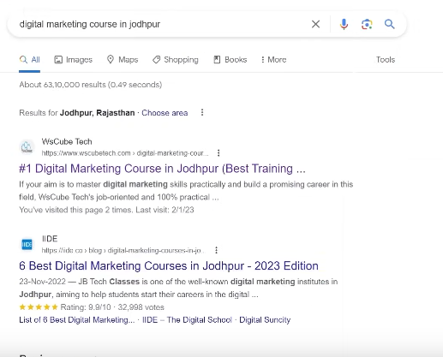

Now you can see there are many results here

Like 1st one is wscube tech

there is now an impression of teacher website but if someone click on it then it will be considered click or view

Now by CTR we mean whatever impression there is of website or campaign how many have clicked on it

Now suppose 100 people search about same think and they see your website link si there are only 100 impressions and among 100 people 15 people click on the link to open the website so our CTR will be 15%



Similarly 200 people has seen your website , your title or description is visible and among 200 60 people have clicked it So out CTR will be 30 percent Googe Search console will tell us about it

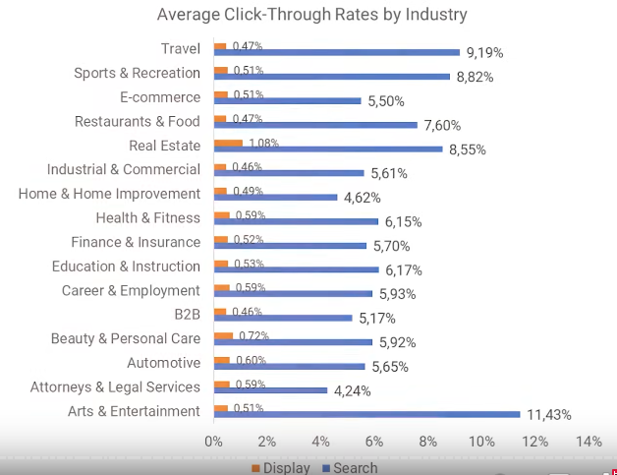

When we will use it we will talk about it but you should know what is CTR

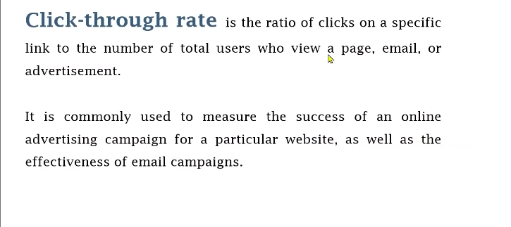

CTR is not just used in case of website It can be used for anything

How many people were shown the ad or webpage and among them who clicked on it   
simiolary in youtube your video reaches people It can happen that it will be shown on youtube home page or in youtube suggestion or someone share it on social Media then that impression is counted and whatever impression is there and how many clicks are there on will be our CTR

Of course it is important for our success that our CTR should increase

More and more people should see our website title in SERP and among them many people will click on it For that you need to make sure your title should be inticing for our website and your description should be inciting that by reading people will click on it and according to user intent your website should be like that

So if we search something like Digital marketing course in Jodhpur

Suppose if there was a page that was ranking lets say cyber security hten will people click on it of course they would not have done it because user need digital marketing course and he is shown us cyber security page so he will not click on it. Because user intent will not be good then how will we get click

So the ways to improve CTR



**Write attractive title**



**Write good description**



**Focus on user intent**

If we have done it then off course our CTR will increase and for your website it is a direct ranking factor remember it

If you want to improve ranking

1:30:30

then by adding such small small thinks our website ranking will be improved

by the way we will talk about other things that will increase our ranking we will talk about other things also due to which the ranking of our site get effected